You are given the root of a binary tree containing digits from 0 to 9 only.

Each root-to-leaf path in the tree represents a number.

* For example, the root-to-leaf path 1 -> 2 -> 3 represents the number 123.

Return *the total sum of all root-to-leaf numbers*. Test cases are generated so that the answer will fit in a **32-bit** integer.

A **leaf** node is a node with no children.

**Example 1:**

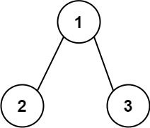

Input: root = [1,2,3]  
Output: 25  
Explanation:  
The root-to-leaf path 1->2 represents the number 12.  
The root-to-leaf path 1->3 represents the number 13.  
Therefore, sum = 12 + 13 = 25.

**Example 2:**

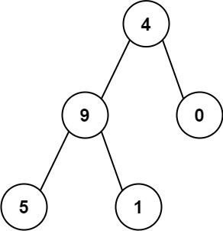

Input: root = [4,9,0,5,1]  
Output: 1026  
Explanation:  
The root-to-leaf path 4->9->5 represents the number 495.  
The root-to-leaf path 4->9->1 represents the number 491.  
The root-to-leaf path 4->0 represents the number 40.  
Therefore, sum = 495 + 491 + 40 = 1026.

**Constraints:**

* The number of nodes in the tree is in the range [1, 1000].
* 0 <= Node.val <= 9
* The depth of the tree will not exceed 10.